A)

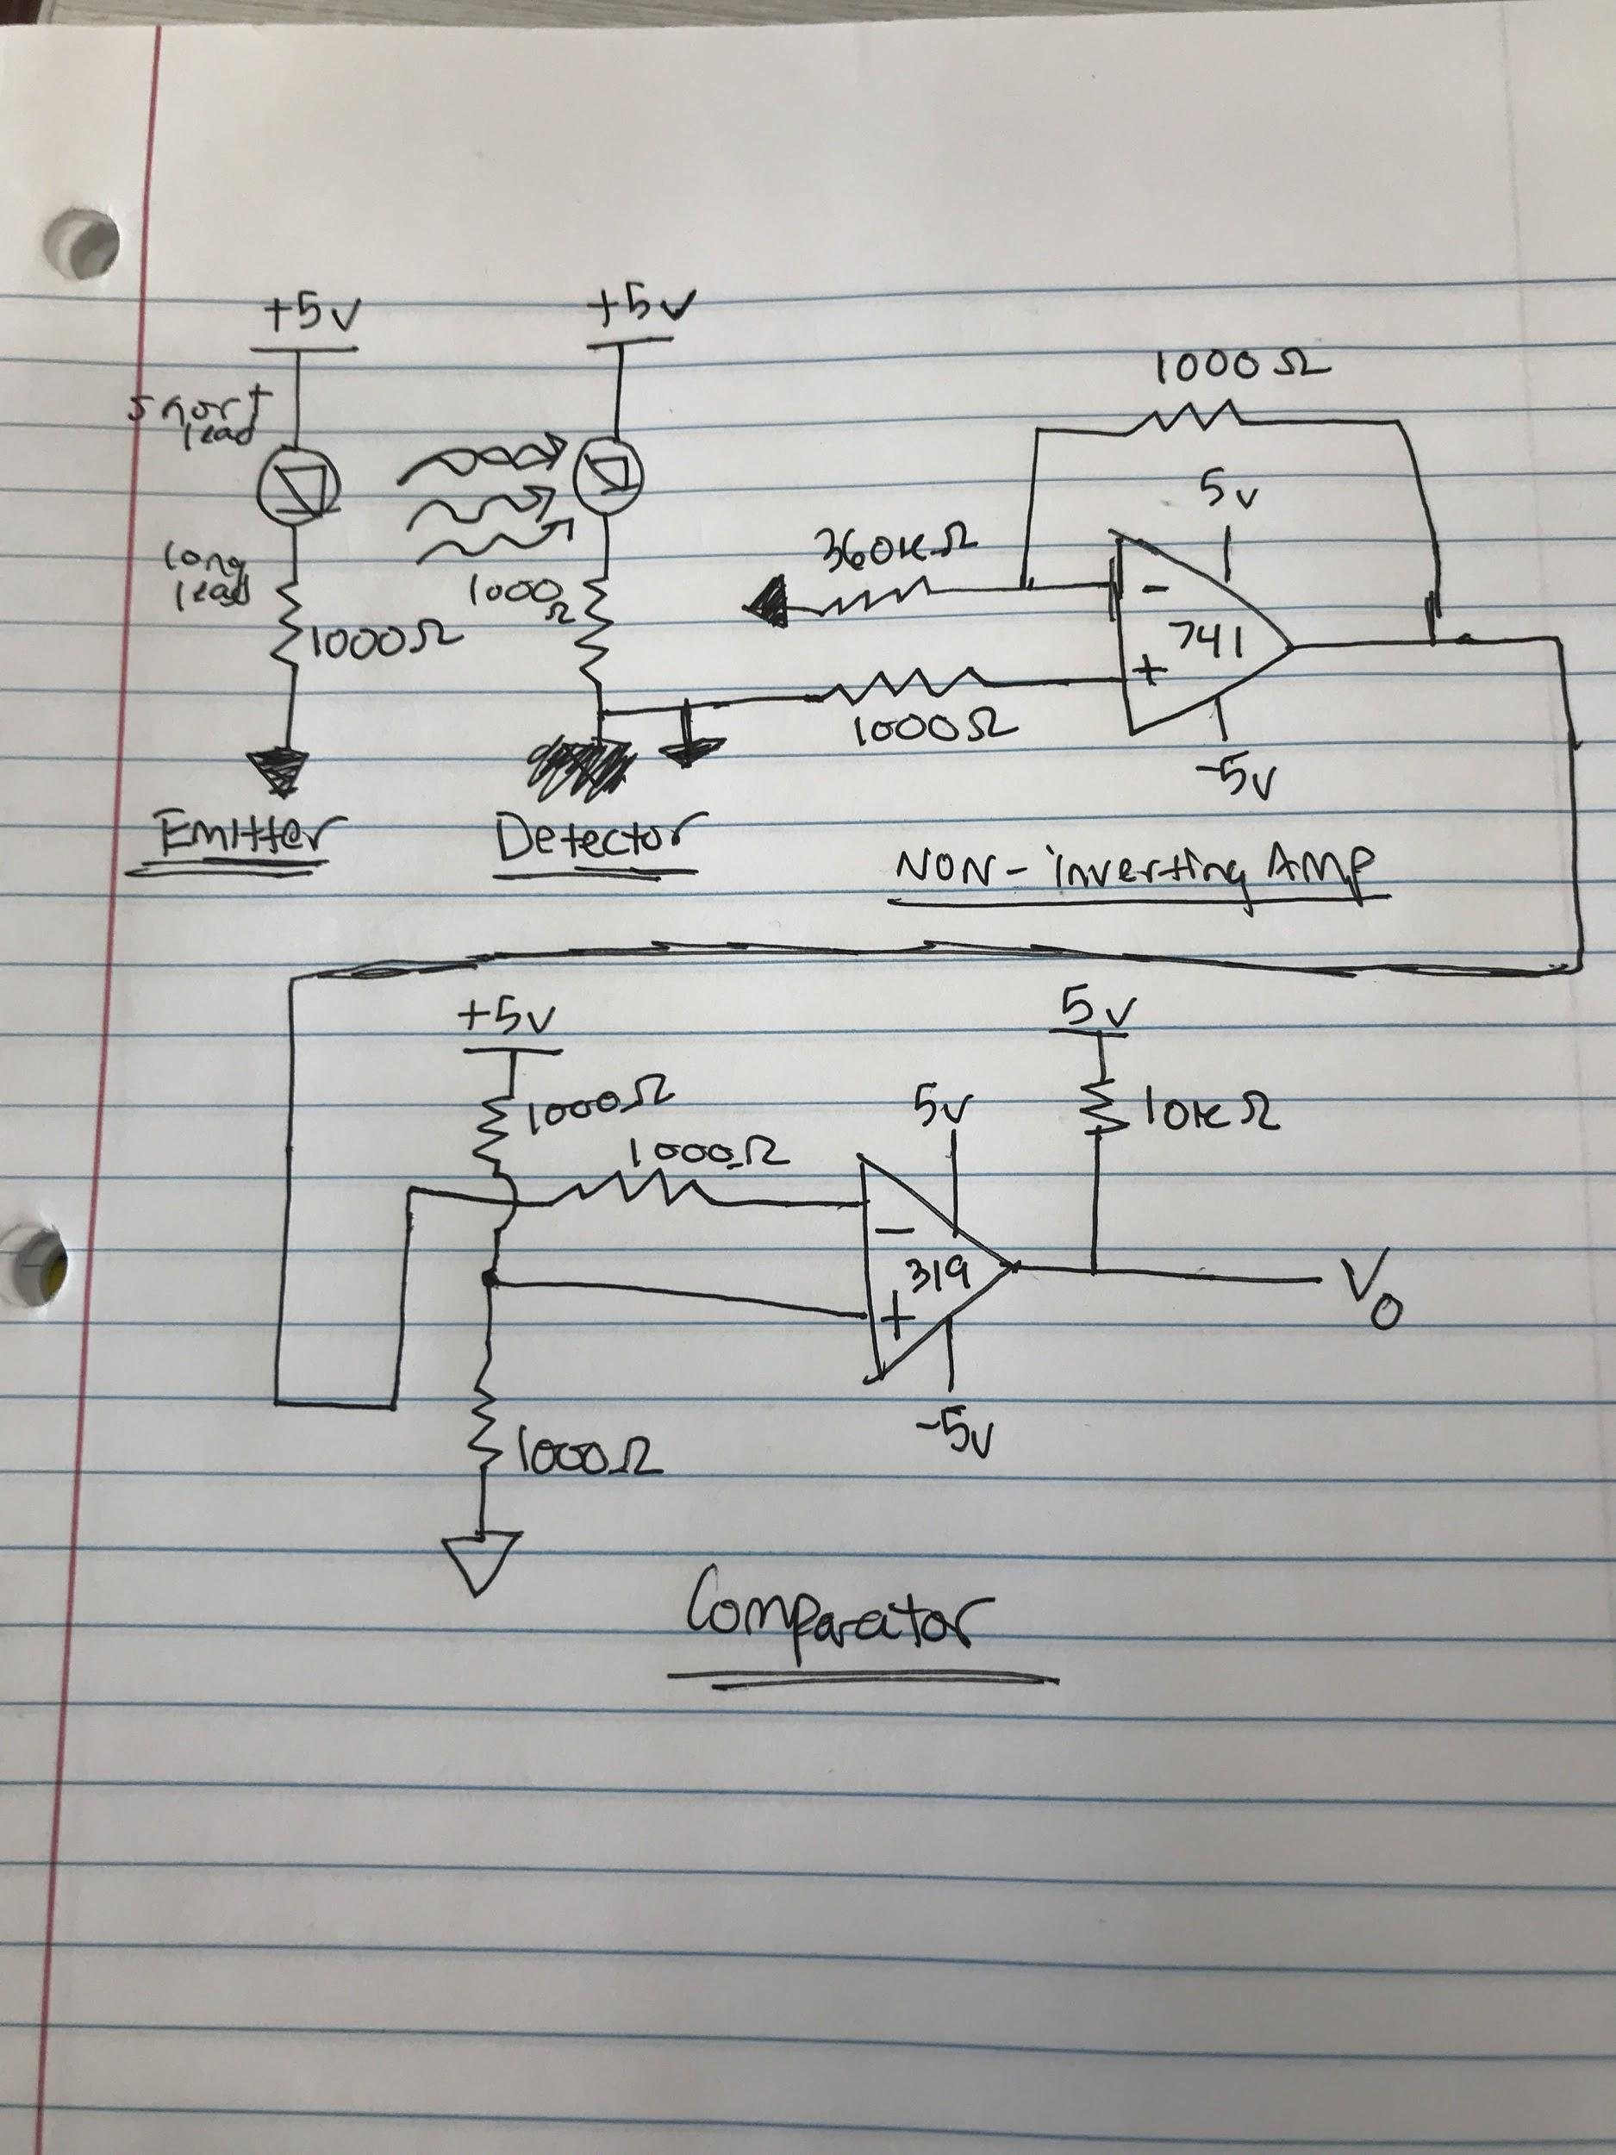

B) 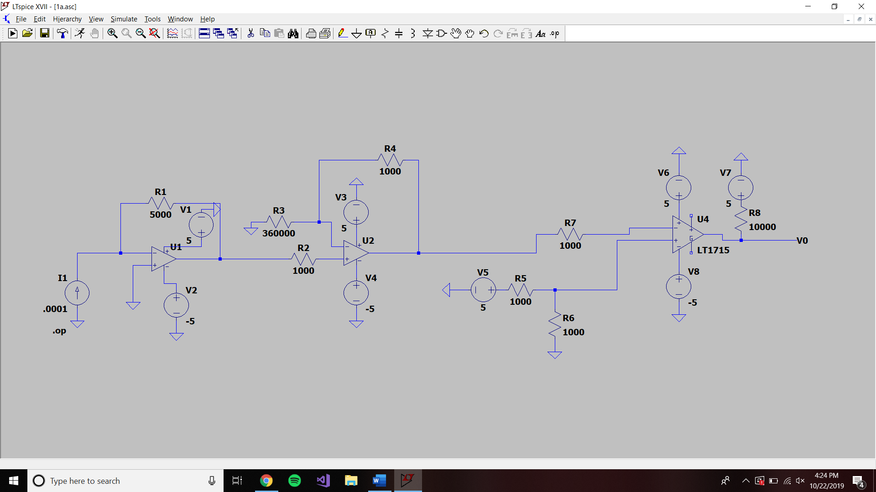

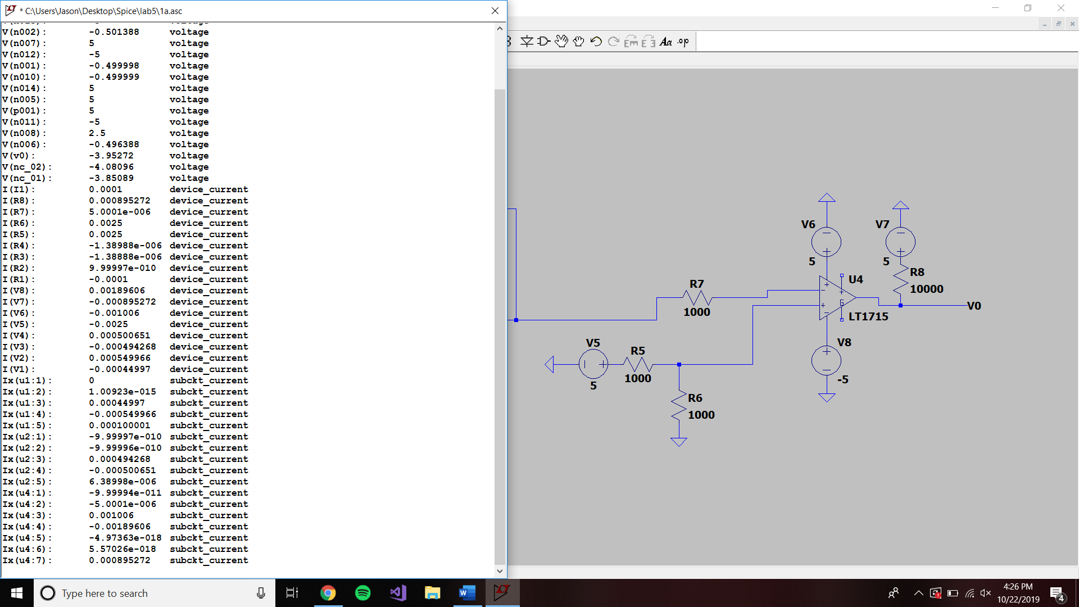

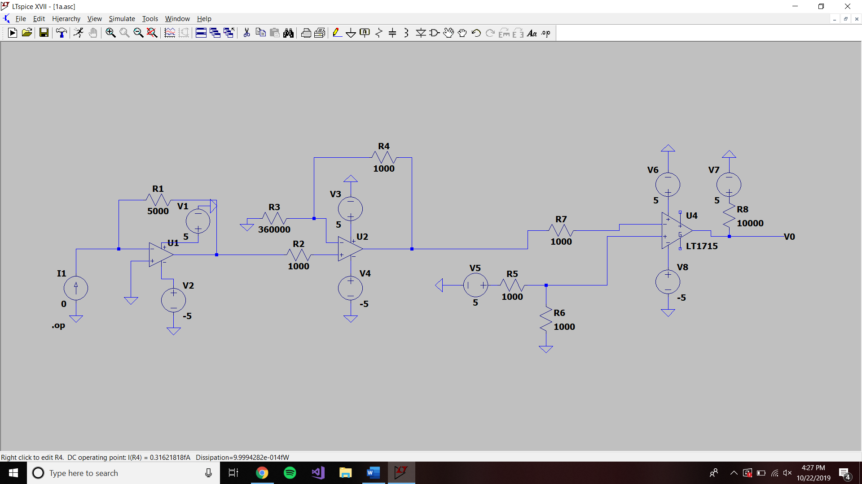

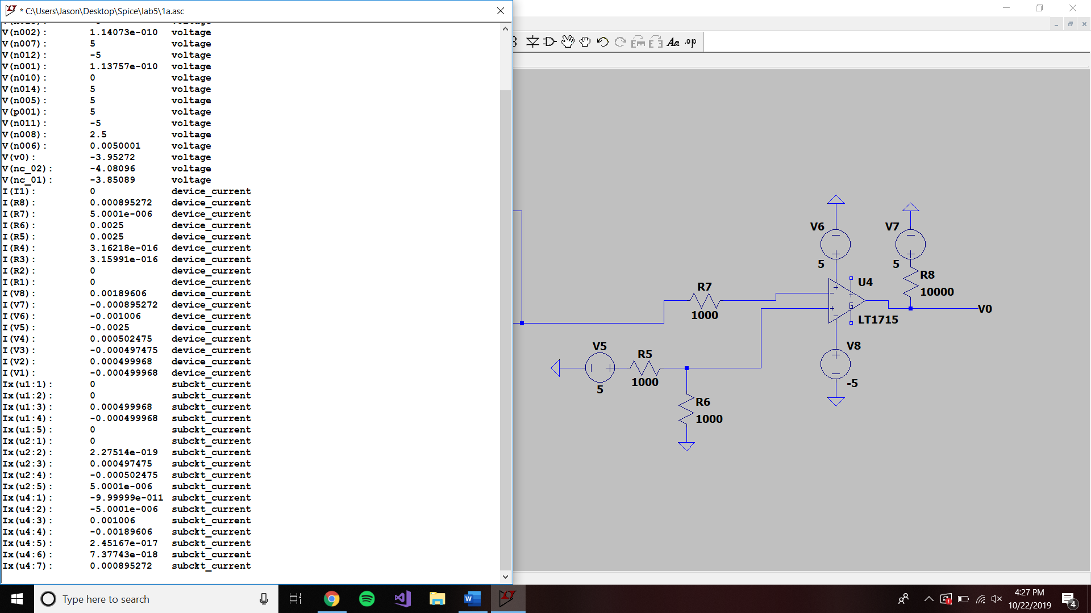

C)

1) alrm is on, short to ground.

S = 0v = Low

R = 5v = High

Q = 5v = High

2) after a, alrm is released

S = 5v = High

R = 5v = High

Q = 5v = High bc of no changing

3) reset is pushed on

S = 5v = High

R = 0v = Low

Q = 0v = Low

4) reset is released

S = 5v = High

R = 5v = High

Q = 0v = Low, no change

D)

V_b = 0v (5-.7)/Rg = positive current across green

Green LED will be on (0-.7)/Rr = negative current across red

Red LED will be off

V_b = 5v

Green LED is off negative current across green

Red LED is on positive current across red

(5-.7)/.01 = Rg = 430 Ohms

(5-.7)/.01 = Rr = 430 Ohms